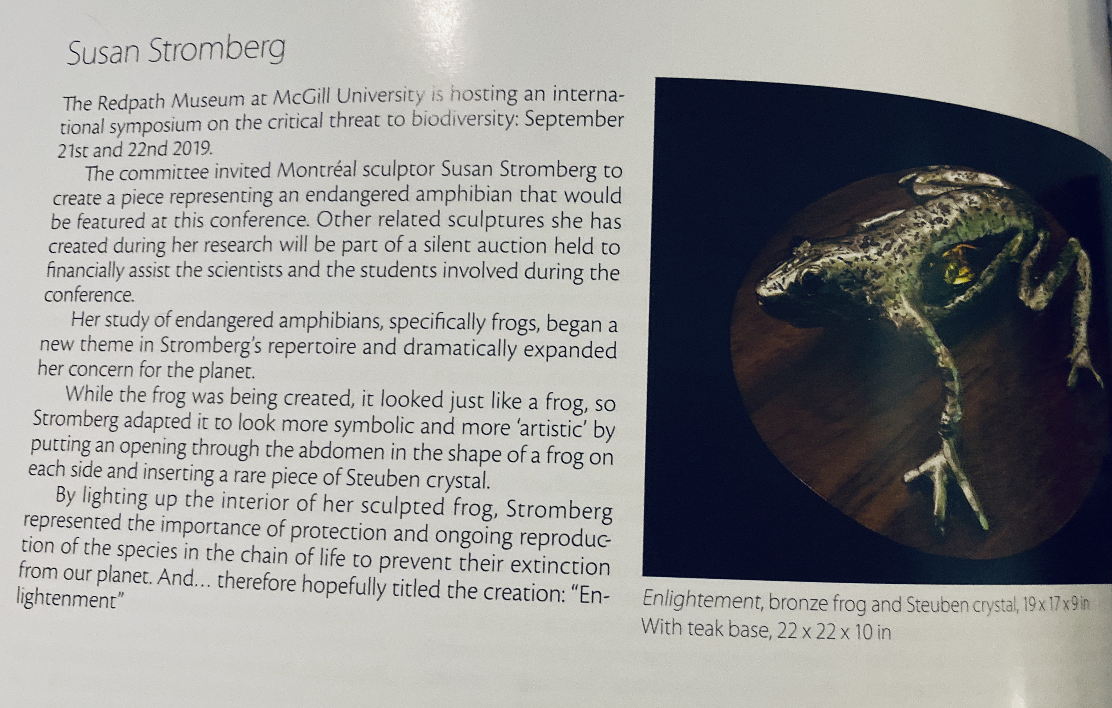

*MAGAZIN’ ART, volume 32, no125, Fall 2019*